- Create an array of 7 daily step counts (e.g., from your phone's fitness app) and write code to calculate the mean (average) number of steps.
ANSWERS:
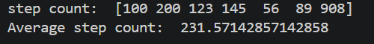

- Given this list of food delivery times in minutes for your last 9 Zomato/Swiggy orders: [32, 28, 29, 45, 30, 31, 60, 30, 29], write a function to find the median delivery time.
ANSWERS:

- Imagine you tracked the genres of 12 YouTube videos you watched this week: ['Music', 'Vlog', 'Music', 'Tech', 'Music', 'Vlog', 'Tech', 'Music', 'Comedy', 'Vlog', 'Music', 'Comedy']. Write code to determine the mode (most watched genre).
ANSWERS:
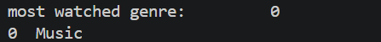

- Take this array of daily UPI transaction amounts (in ₹): [100, 120, 105, 110, 5000, 115, 108]. Calculate both the mean and the median, then explain in 2-3 lines which is a better measure of your 'typical' transaction and why.

Hint: Consider the effect of the ₹5000 value.
ANSWERS:
The median (₹110) is a much better measure of a "typical" daily transaction than the mean.
The single ₹5000 transaction is an extreme outlier (like buying a smartphone or paying rent). It heavily distorts the mean, pulling it up to ₹808.29, which doesn't reflect the user's usual minor daily expenses. The median completely ignores this outlier and correctly captures the center of the normal everyday transactions.

